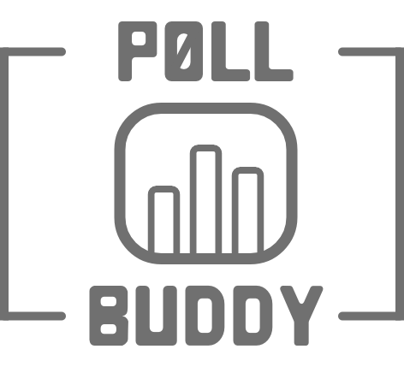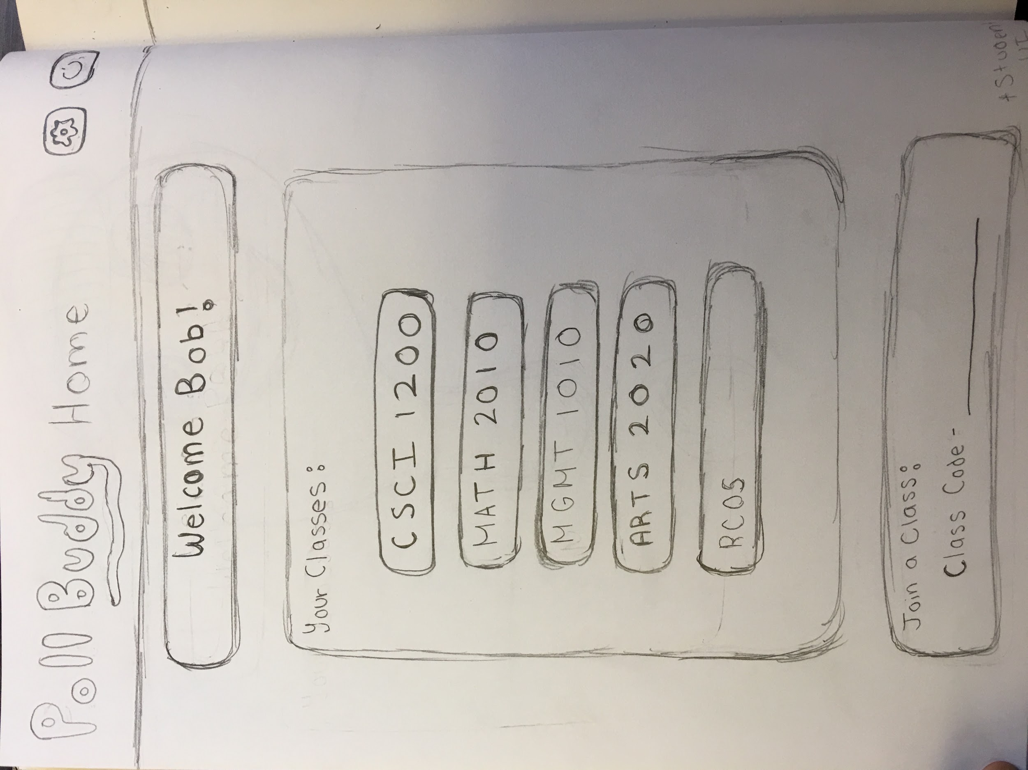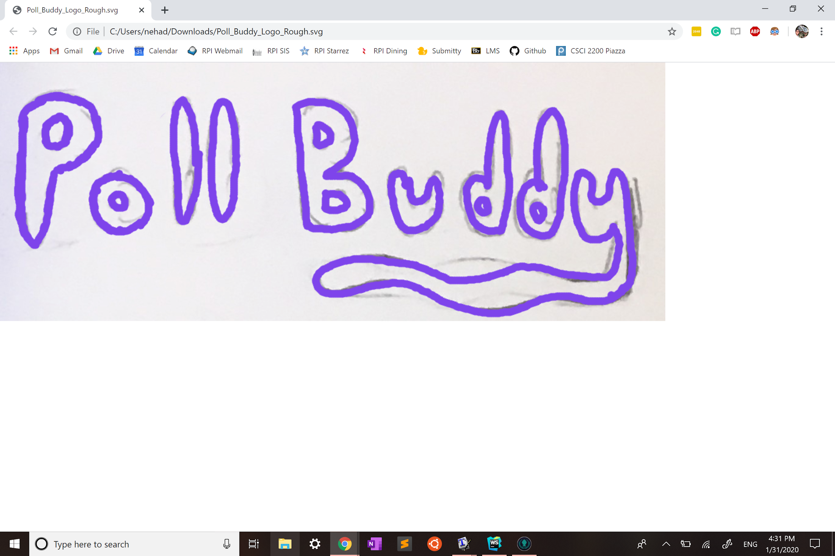

**PollBuddy**

**Introduction:**

* Many professors use iClickers to ask questions or polls to their students.
* However, iClickers are expensive, bulky, outdated, easy to forget, difficult to integrate with other programs, and only professors can track answers.
* Therefore, we decided to create a website that has similar, yet improved functionality of iClickers, called **PollBuddy**.
* PollBuddy is a website that professors can use to interact with students during class. Professors will log on to their PollBuddy website and will be able to create questions. Students will be able to log in to their accounts where they will be able to see the answer options and will be able to get PollBuddy points for answering them. Students will be able to view their PollBuddy points at any time.

**Languages:** Frontend: HTML, CSS, React?

Backend: NodeJS, MongoDB, Express

**Feature Milestones:**

* End of January:
  + Proposal
  + Decide on frontend language
* End of February:
  + Outline website flow/wireframes
  + Diagram pages
  + Remove sample website, create real home page
  + Login page
  + (add more pages as outlining completes)
  + More client-server communication
  + Backend: User routes
  + Contingency: If the website still looks like it does at the end of January, React is getting scrapped and we are switching to HTML/CSS.
* End of March
  + Rough UI (utilizing wireframes and page diagrams from before)
* End of April
  + Mostly complete UI
* End of May
  + Minimum viable product, beta version should be able to roll out Arch 2020

**Team Members:**

PollBuddy **Alex Bozeat** [**bozeaa@rpi.edu**](mailto:bozeaa@rpi.edu)

PollBuddy **Annie Shi** [**shia@rpi.edu**](mailto:shia@rpi.edu)

PollBuddy **Ashwin Chitoor** [**chitoa@rpi.edu**](mailto:chitoa@rpi.edu)

PollBuddy **Hunter Harris** [**harrih3@rpi.edu**](mailto:harrih3@rpi.edu) **(PM)**

PollBuddy **Jason Lam** [**lamj7@rpi.edu**](mailto:lamj7@rpi.edu)

PollBuddy **Joe Chu** [**chuj6@rpi.edu**](mailto:chuj6@rpi.edu)

PollBuddy **Joe Halasz** [**jhalaszsign@gmail.com**](mailto:jhalaszsign@gmail.com)

PollBuddy **Kevin Cheng** [**kcheng5@rpi.edu**](mailto:kcheng5@rpi.edu)

PollBuddy **Kevin Lee** [**leek16@rpi.edu**](mailto:leek16@rpi.edu)

PollBuddy **Neha Deshpande** [**deshpn2@rpi.edu**](mailto:deshpn2@rpi.edu)

PollBuddy **Nicholas Bezanis** [**bezann@rpi.edu**](mailto:bezann@rpi.edu)

PollBuddy **Reed Metzler-Gilbertz** [**meltzr@rpi.edu**](mailto:meltzr@rpi.edu)